**ACCELERATOR PEDAL POSITION SENSOR(APPS)**

Made by: Abhinav Kumar Date:02/02/2024

**OBJECTIVE**

APPS is a sensor used in the vehicle's throttle system to measure the position of the accelerator pedal. In an EV, the accelerator pedal position is translated into an electrical signal by the APPS, which is then interpreted by the vehicle's motor controller. Based on this input, the motor controller adjusts the power output of the electric motor(s) to accelerate the vehicle accordingly

**RULES**

* The APPS must be actuated by a foot pedal.
* Pedal travel is defined as the percentage of travel from fully released position to a fully applied position where 0% is fully released and 100% is fully applied.
* The foot pedal must return to the 0% position when not actuated. The foot pedal must have a positive stop preventing the mounted sensors from being damaged or overstressed. Two springs must be used to return the foot pedal to the 0% position and each spring must work when the other is disconnected. Springs in the APPS are not accepted as return springs.
* At least two separate sensors must be used as APPSs. Separate is defined as not sharing supply or signal lines.
* If analog sensors are used, they must have different, non-intersecting transfer functions. A short circuit between the signal lines must always result in an implausibility .
* The APPS signals are SCSs .
* If an implausibility occurs between the values of the APPSs and persists for more than 100ms then the power to the motor(s) must be immediately shut down completely. It is not necessary to completely deactivate the tractive system, the motor controller(s) shutting down the power to the motor(s) is sufficient.
* Implausibility is defined as a deviation of more than ten percentage points pedal travel between any of the used APPSs or any failure according to .
* If three sensors are used, then in the case of an APPS implausibility, any two sensors that are plausible may be used to define the torque target and the 3rd APPS may be ignored.
* It must be possible to separately disconnect each APPS signal wire to check all functionalities.
* A fully released accelerator pedal must result a wheel torque of ≤0 Nm.
* The commanded motor torque must be 0 Nm if hard braking occurs**and the APPS signals pedal travel equivalent to ≥25% desired motor torque or ≥5 kW, whichever is lower, at the same time for more than 500ms.

**To detect hard braking, a brake system pressure sensor must be used. The threshold must be chosen such that there are no locked wheels and the brake pressure is ≤ 30 bar.

* The commanded motor torque must remain at 0Nm until the APPS signals less than 5% pedal travel and 0Nm desired motor torque, regardless of whether the brakes are still actuated or not.

Components Required

|  |  |  |  |
| --- | --- | --- | --- |
| S.no | Name of Component | Application | Specification(Quantity) |
| 1. | Arduino | To run the code | Arduino Uno or nano (1) |
| 2. | Potentiometers | Pot1,Pot2-For showing the accelerator pedal position  Pot3-For showing the brake pedal position | 10kohm (3) |
| 3. | Jumper Wires | To make connections in breadboard | (As per requirement) |
| 4. | LED | To show the change in motor torque | Red(1) |
| 5. | Breadboard | To make connections with components | Half breadboard(1) |

Block diagram

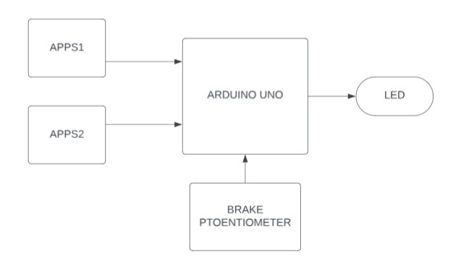

Circuit Diagram

**POT1 & POT2-**give position of accelerator pedal as input to arduino

**Brakes**-gives position of brake pedal as input to arduino

**Led**- We have used it to represent motor torque instead of motor

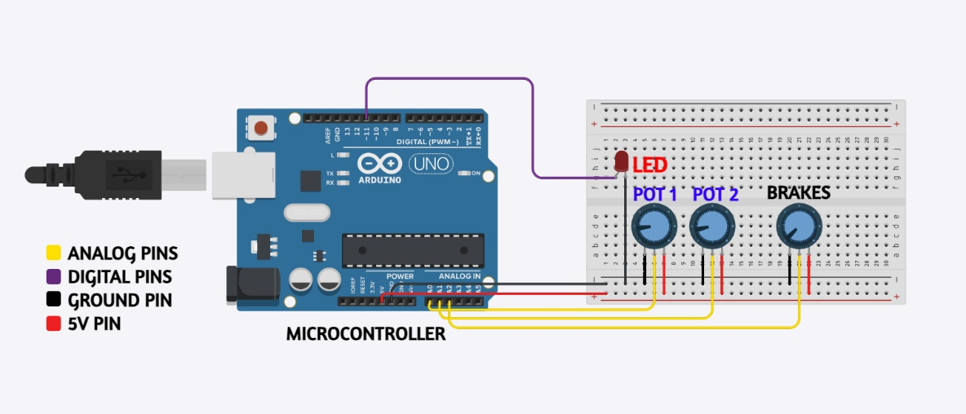

Working Principle

* Pedal travel is defined as the percentage of travel from fully released position to a fully applied position where 0% is fully released and 100% is fully applied.
* We use potentiometers as sensor, potentiometer-fully rotated 100%,potentiometer -not rotated 0%.
* Two separate sensors must be used as APPSs .This is done because in case of any failure in one potentiometer the other potentiometer gives the desired output.
* The **brightness of the LED varies as we vary the APPS values** (50%- half brightness,100%- full brightness) representing how the motor torque varies as the accelerator pedal position changes.
* **Implausibility** is defined as a **deviation of more 10%** points pedal travel between any of the used APPSs (apps1-40%,apps2-55% ERROR ) for **100ms.**
* After error due to deviation occurs **led turns off** and when the deviation reduces below 10% the led glows depending on the position of the pedal.
* Another **implausibility** is if **apps >25%** & **brake >25%** for more than **500ms .**

So in this case the car can skid so to prevent this the motor torque should be 0Nm.So the LED turns OFF and remains OFF until brake<5% and we have to bring

* We have set the **threshold** for hard braking as **25% .**

**Arduino Code-** [**Click here**](https://drive.google.com/file/d/1lHlhX9-nT0Hofym_opD6YTLJogM94ZKV/view?usp=drivesdk)

**To see all the possible results-** [**Click here**](https://drive.google.com/file/d/1lRsC9M0Z_0D45YXLtP4wkLdiwS-a6acN/view?usp=drivesdk)